**Admin**

* Manage reports (Date selection need to include in every report)
  + Highly purchased shop
  + Registered customers list (Daily, Monthly, Yearly)
  + Registered Hardware list (Daily, Monthly, Yearly)
* Can manage system users.
* Can see the highly purchased hardware
* Revenue report (admin can receive a revenue because he will get a commission when a hardware register continues to use the service after the first year)
* Can manage hardware registrations and customer registrations
* Validate forms
* Ban band hardwares if they have negative feedback

**Customer**

* Customer purchase history (Generate Report) [Dates can be selected]
* Register to the application
* Log in to the application.
* Customer can manage their accounts.
* There are two options:
  + Customer location will be identified by the address when the user gives in their registration. If they want to order for a different location, they can enter the location and app will suggest the nearest hardware's according to the least to highest prizes
    - App will suggests the nearest hardware's (within 2-5km)
  + There is another option that the customers can browse a product on search bar and application will all the available product prices. So, the customer can compare prices of the products. As an example, assume that a customer browse cement as the product on search bar, then they can see the list of cement and prices with the name of the hardware. So, the customer can compare prices of each hardware. (prize list will be shown from least to highest)
* Choose the hardware or item (1st or 2nd option)
* List of available items with the price (Provide an up-to-date list)
* customer can choose one or more items according to their needs
* There should be a cart to add items to customers
* They can add or delete item from the cart before confirmation
* They can see their cart and it displays the prices for selected items
* Delivery cost also be shown in the screen after selecting goods. (delivery cost should be calculated)
* If they select the hardware they can see the delivery cost for the selected hardware.
* Then the screen shows the order detail and confirm button.
* When the order is confirmed, they will get a message from hardware saying order confirmed.
* Then the system asked to do the payments. The payments can be done online using credit cards
* Customer have to complete payment details
* Customer can message to the hardware through the application.
* Customer gets and email of the invoice to their registered email
* Customer can view the order.
* customers will be getting a notification saying, "Your order is ready"
* Customer gets messages like they will be getting the order around two minutes, five minutes and so on

**Hardware owner**

* Generate reports
  + Hardware can see the average sales (daily, Monthly, Weekly)
  + Highly purchased item
  + Profit report
* Hardware can register freely, and they should pay a yearly payment to use the application after 1 year.
* Hardware items list
* Add/update or delete an item from the list
* Update prices for available items
* Update available quantities of each item
* Update descriptions for each product (if necessary)
* Update pictures for each product
* When a customer has placed an order, the hardware can review the order from the database.
* When the customer confirmation is done, the hardware employees quickly go through the order and check that items are available.
* After that they send a confirmation message with the delivery cost to the customers.
* Accepts payments online through credit/debit card.
* When payment is done hardware will process the order.
* Hardware will assign a vehicle
* After the customer do the payment the hardware sends a notification saying, "Your order is ready". Customer gets messages like they will be getting the order within two minutes, five minutes and so on. (Driver's phone number and vehicle number should be included in the notification) {when the app is open}
* When a customer has placed an order invoice will be sent to their registered email
* Hardware name will be pop on the map when the mouse hover over it (Additional)
* Track the order (Additional)

………………………………………………………………………………………………………

* Need to validate each form and buttons
* Need to be user friendly
* Attractiveness
* Websites need to be host
* Some small features will be added in the future (According to my supervisor)
* All the interfaces need to be finished before January 21st, 2021

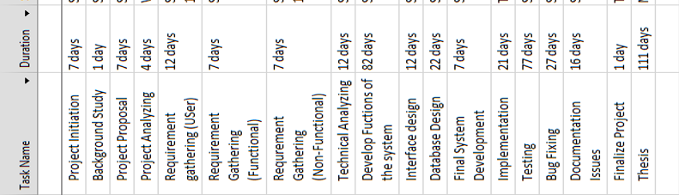

……………………… ..……………………

Vishmi